SQL for E-commerce Database Management System

-- Creates the 'customers' table
-- Demonstrates PRIMARY KEY, VARCHAR, UNIQUE, NOT NULL constraints
CREATE TABLE customers (
customer_id VARCHAR(10) PRIMARY KEY,
name VARCHAR(100) NOT NULL,
email VARCHAR(100) NOT NULL UNIQUE,
phone VARCHAR(20)
);

-- Populate 'customers'
INSERT INTO customers (customer_id, name, email, phone) VALUES
('c1', 'Alice Smith', 'alice@example.com', '555-0101'),
('c2', 'Bob Johnson', 'bob@example.com', '555-0102'),
('c3', 'Charlie Lee', 'charlie@example.com', '555-0103');

SELECT * FROM customers;

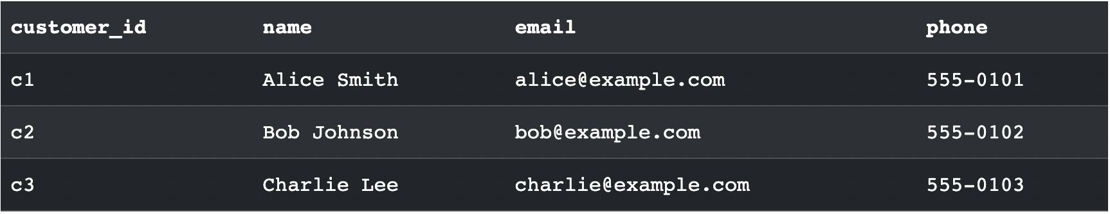

-- Creates the 'products' table
-- Demonstrates DECIMAL, INT, and CHECK constraints
CREATE TABLE products (
product_id VARCHAR(10) PRIMARY KEY,
name VARCHAR(100) NOT NULL,
price DECIMAL(10, 2) NOT NULL CHECK (price >= 0),
stock INT NOT NULL CHECK (stock >= 0)
);

-- Populate 'products'
INSERT INTO products (product_id, name, price, stock) VALUES
('p1', 'Laptop', 1200.00, 10),
('p2', 'Mouse', 25.00, 50),
('p3', 'Keyboard', 75.00, 30),
('p4', 'Monitor', 300.00, 0),
('p5', 'Headphones', 150.00, 20);

SELECT * FROM products;

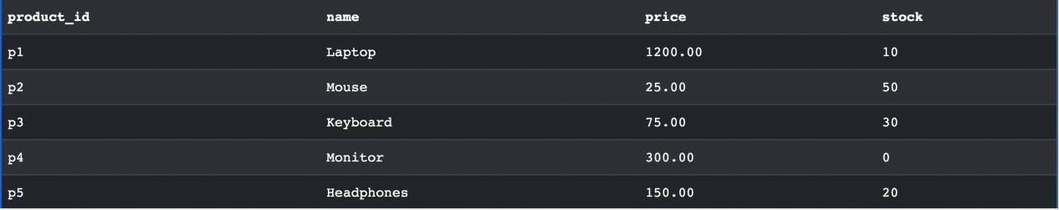

-- Creates the 'orders' table
-- Demonstrates FOREIGN KEY, TIMESTAMP, and DEFAULT constraints
CREATE TABLE orders (
order_id VARCHAR(10) PRIMARY KEY,
customer_id VARCHAR(10) NOT NULL,
order_date TIMESTAMP DEFAULT CURRENT_TIMESTAMP,
status VARCHAR(20) NOT NULL DEFAULT 'Pending',
FOREIGN KEY (customer_id) REFERENCES customers(customer_id)
);

-- Populate 'orders'
-- Note: Timestamps are explicit for consistent sample data
INSERT INTO orders (order_id, customer_id, order_date, status) VALUES
('o1001', 'c1', '2023-10-15 10:30:00', 'Shipped'),
('o1002', 'c2', '2023-10-18 14:45:00', 'Processing'),
('o1003', 'c1', '2023-11-01 09:15:00', 'Delivered'),
('o1004', 'c3', '2023-11-05 11:00:00', 'Shipped'),
('o1005', 'c2', '2023-11-07 16:20:00', 'Pending');

SELECT * FROM orders;

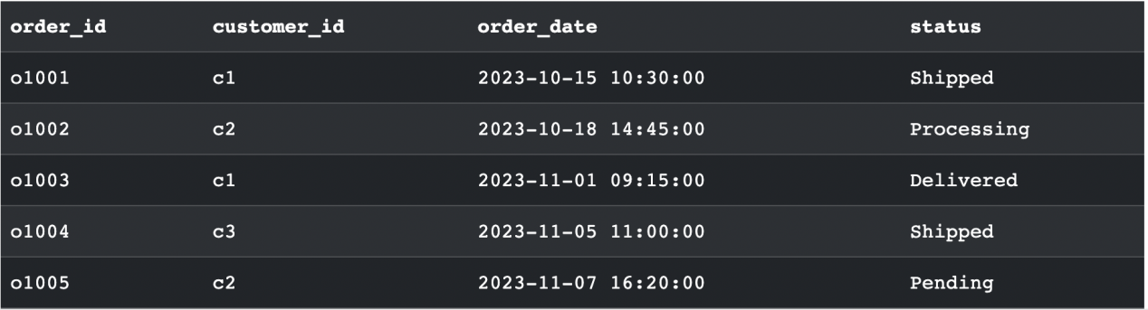

-- Creates the 'order_details' table (a junction table)
-- Demonstrates a composite PRIMARY KEY and multiple FOREIGN KEYs
CREATE TABLE order_details (
order_detail_id VARCHAR(10) PRIMARY KEY,
order_id VARCHAR(10) NOT NULL,
product_id VARCHAR(10) NOT NULL,
quantity INT NOT NULL CHECK (quantity > 0),
unit_price DECIMAL(10, 2) NOT NULL,
FOREIGN KEY (order_id) REFERENCES orders(order_id),
FOREIGN KEY (product_id) REFERENCES products(product_id)
);

-- Populate 'order_details'
INSERT INTO order_details (order_detail_id, order_id, product_id, quantity, unit_price) VALUES
('od1', 'o1001', 'p1', 1, 1200.00),
('od2', 'o1003', 'p2', 1, 25.00),
('od3', 'o1002', 'p3', 1, 75.00),
('od4', 'o1005', 'p5', 1, 150.00);

SELECT * FROM order_details;

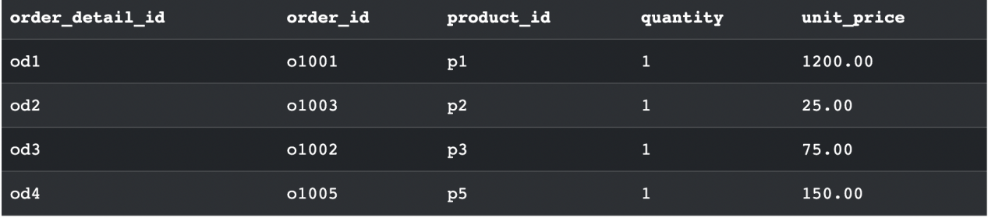

-- Creates the 'payments' table
-- Demonstrates another FOREIGN KEY and DECIMAL
CREATE TABLE payments (
payment_id VARCHAR(10) PRIMARY KEY,
order_id VARCHAR(10) NOT NULL,
amount DECIMAL(10, 2) NOT NULL,
payment_date TIMESTAMP DEFAULT CURRENT_TIMESTAMP,
method VARCHAR(50),
FOREIGN KEY (order_id) REFERENCES orders(order_id)
);

-- Populate 'payments'
INSERT INTO payments (payment_id, order_id, amount, payment_date, method) VALUES
('pay1', 'o1001', 1225.00, '2023-10-15 10:32:00', 'Credit Card'),
('pay2', 'o1002', 225.00, '2023-10-18 14:46:00', 'PayPal'),
('pay3', 'o1003', 50.00, '2023-11-01 09:16:00', 'Credit Card'),
('pay4', 'o1004', 300.00, '2023-11-05 11:01:00', 'PayPal'),
('pay5', 'o1005', 1200.00, '2023-11-07 16:21:00', 'Credit Card');

SELECT * FROM payments;

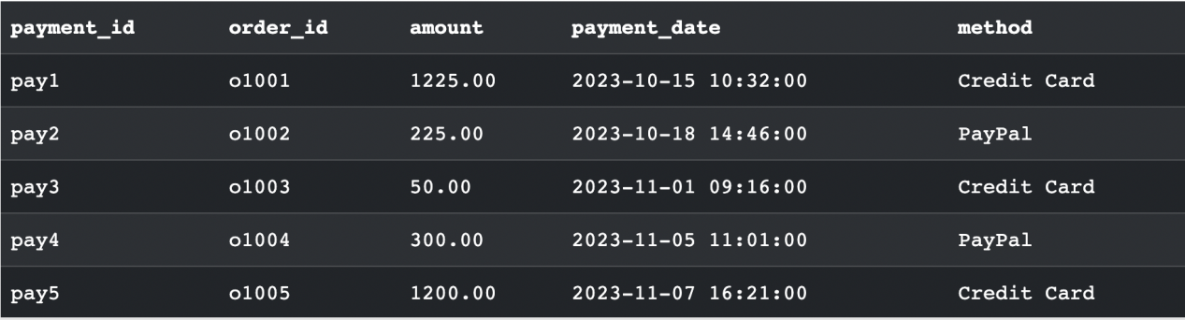

Few queries

Retrieve all orders placed by specific customer

SELECT
o.order_id,
o.order_date,
o.status,
p.name AS product_name,
od.quantity,
od.unit_price
FROM orders o
JOIN order_details od ON o.order_id = od.order_id
JOIN products p ON od.product_id = p.product_id
WHERE o.customer_id = 'c1';

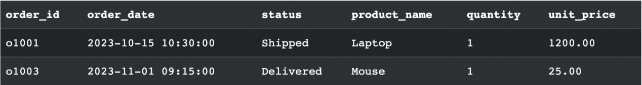

Calculate the total revenue for the given month.

SELECT
SUM(amount) AS total_revenue
FROM payments
WHERE MONTH(payment_date) = 10 AND YEAR(payment_date) = 2023;

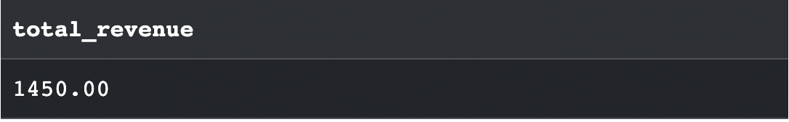

Finding products that are out of stock

SELECT
product_id,
name,
price
FROM products
WHERE stock = 0;

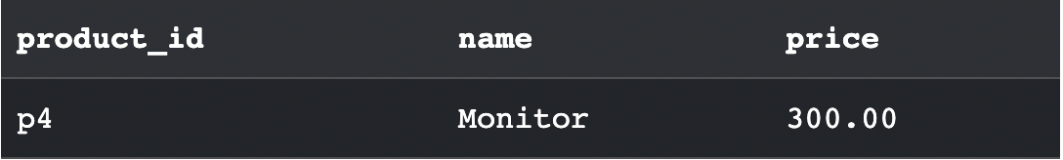

Updating customer information.
(it demonstartes an UPDATE statement)

UPDATE customers
SET phone = '555-0199'
WHERE customer_id = 'c3';

